**Lab 2: Downloading Census and American Community Survey Data**

**1. Learning objectives**

* To become familiar with data published by the US Census Bureau.
* To practice using the sources that you need in order to obtain this data.
* To gain the skills to jump into Assignment 1!

**2. Exercise: Find a census tract**

* Go to [US boundary](http://www.usboundary.com/Areas/Census%20Tract/California/Alameda%20County). This website is handy for identifying the geography of your census tract. This is a really good idea if you want to use this lab to get started on Assignment 1. Explore this site - click on “Data on map.”
* Go to American FactFinder on your web browser at <http://factfinder.census.gov>
* Select the “street address” link halfway down the page in the right-hand column.
* Punch in an address—maybe where you live, or a place you’re interested in the Bay Area, or a place you are researching for class and click “Go.”
* Click on your census tract where it appears under “Geography Results.” You will notice that it appears under “Your Selections” in the upper left corner of the browser window.
* Click on the “Map” tab under the “Select Geographies” header to see a map of the census tract where you live.
* Note: 2011–2017 ACS data uses the tract boundaries established for the 2010 Census. 2000 Census and earlier ACS tracts may be different.

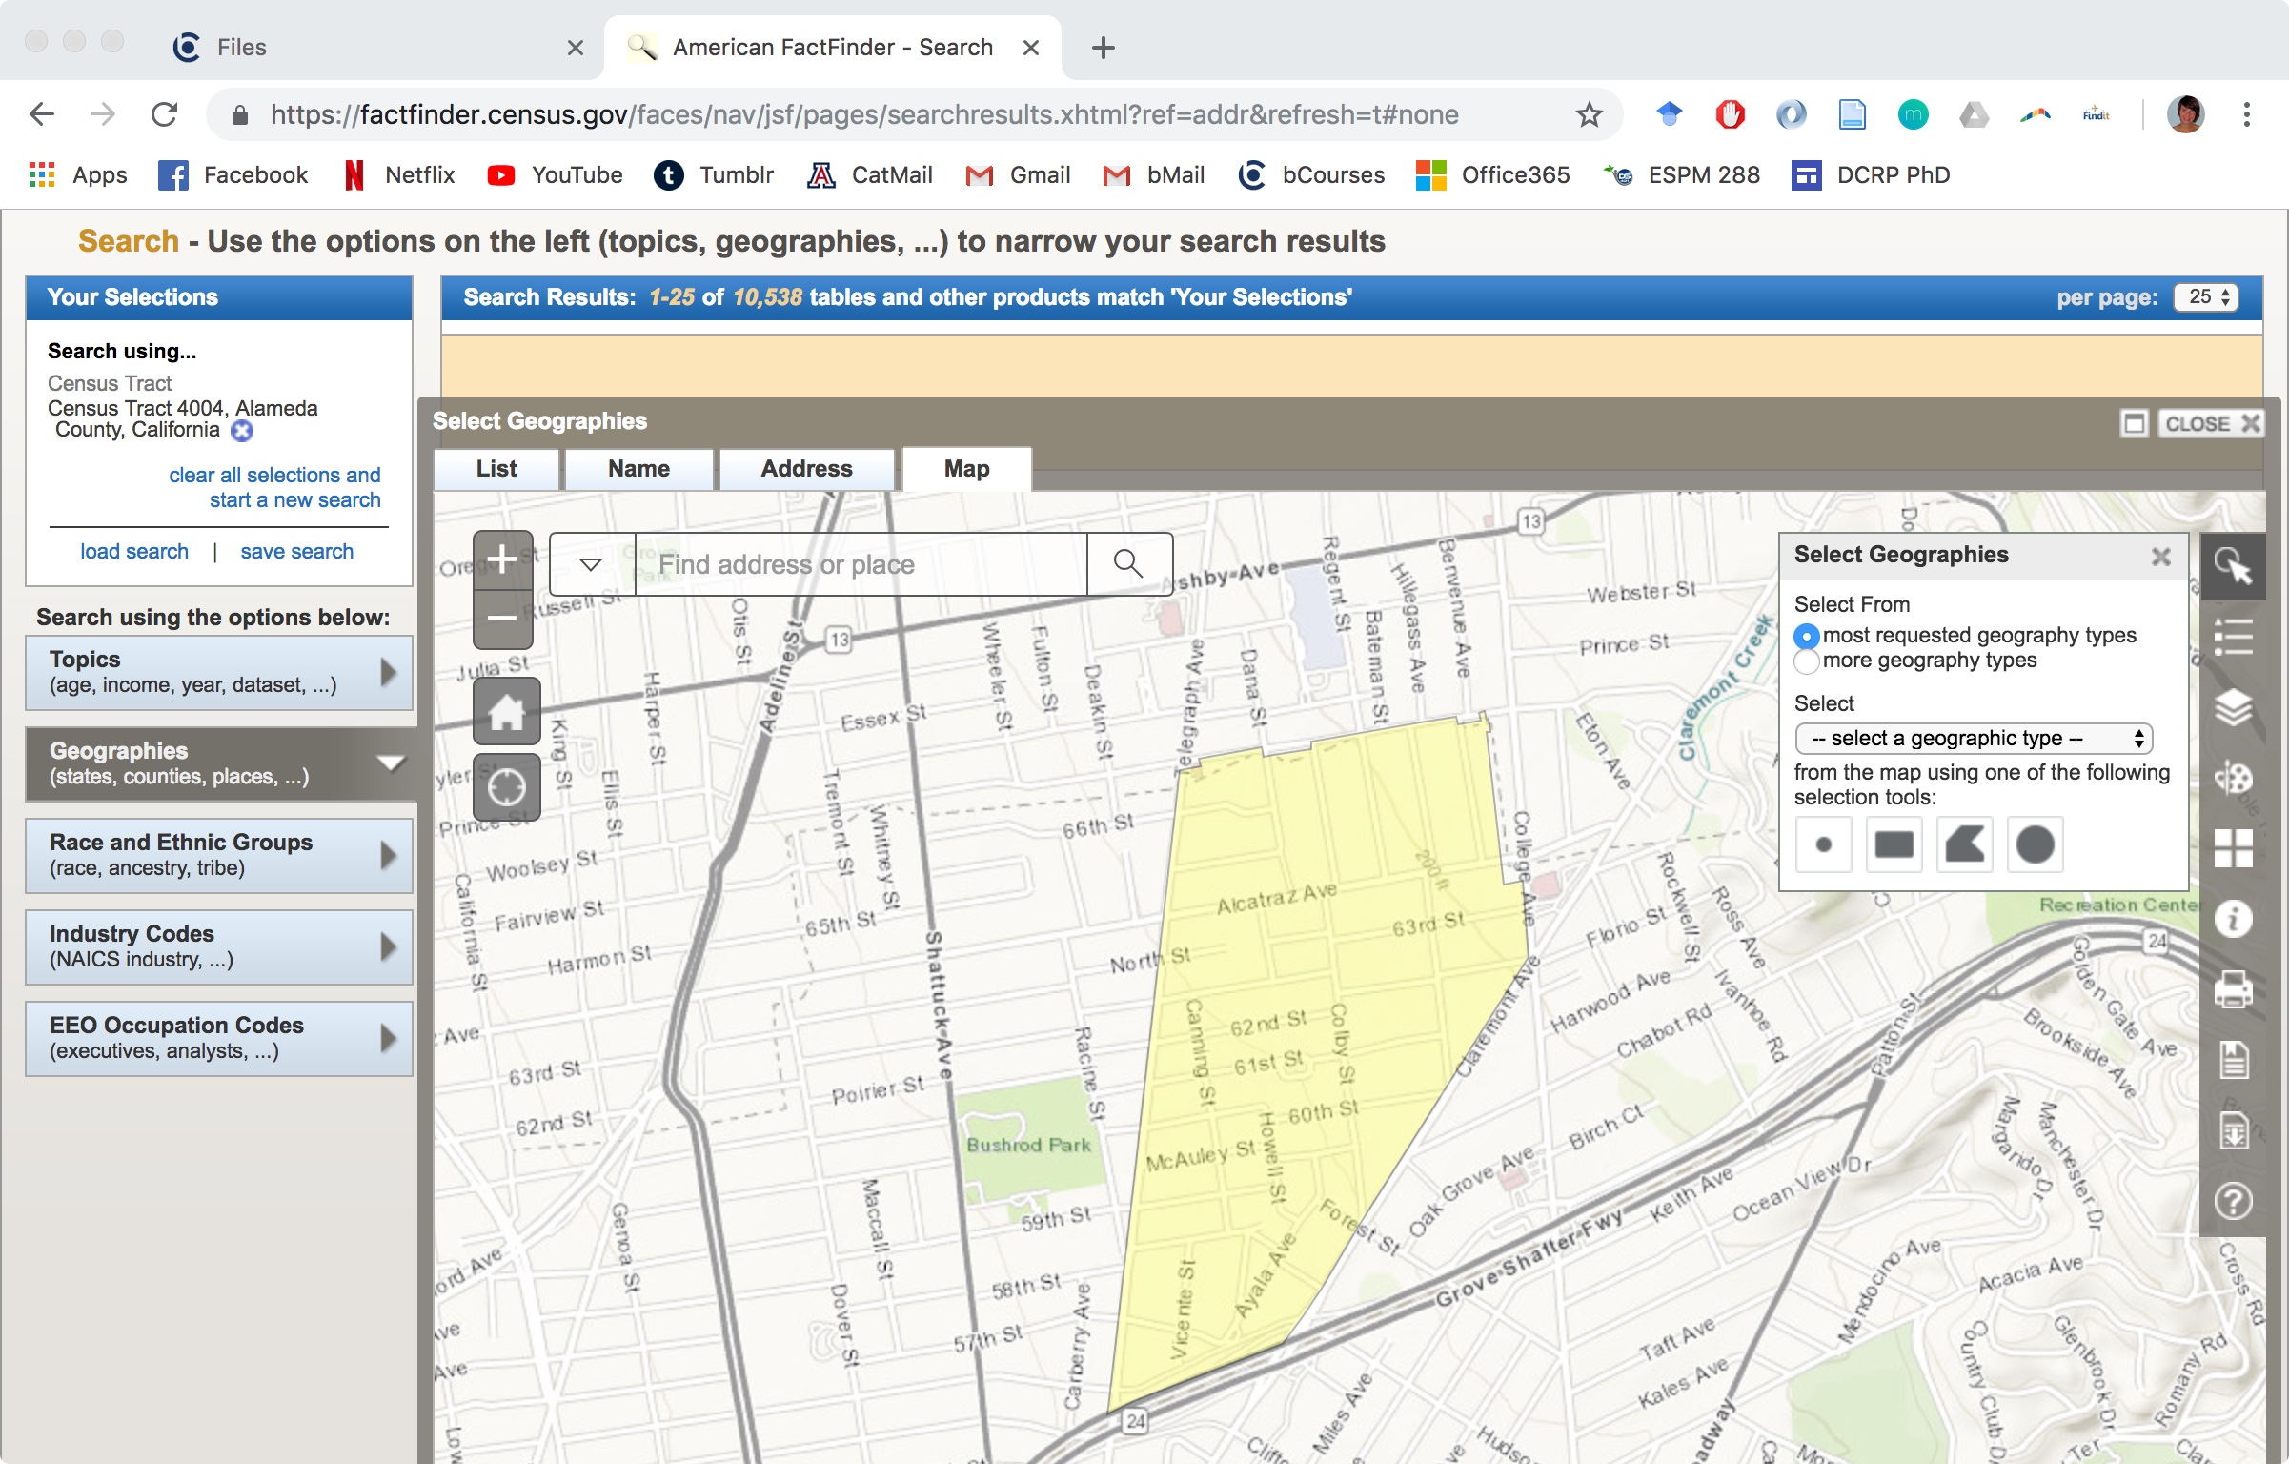

* You can also find your census tract by searching using the “Geographies” search option, and selecting the “List” tab. Generally, you can select from “most request geographic types.” But, for now, stick with “all geographic types.” Take a look at the “Select a geographic type” drop-down menu. Select the first instance of “Census Tract (or part).” (You can also search “Census Tract”.) Then select your state (“California”), and your county (“Alameda”), and your county subdivision (this depends on your tract, for 4004 - shown above - I would select “Oakland”), and your place/remainder (“Oakland”), and then, finally, your Census Tract. Note that this is likely more cumbersome than using the “Address” search features - but works if you know what you’re trying to get, or are trying to get, say, all census tracts within a larger geography (like a county).

**3. Exercise: Downloading ACS data for a census tract or city**

* Select “close” in the upper right corner of the “Select Geographies” window to make this window go away.
* Next, let’s also select the city that the tract is located in, so that we can compare the tract data to citywide data. Start by clicking on the “Geographies” tab on the left panel. Go to the “List” tab. You can select the city by picking “Place” from the “geographic type” drop down menu. Then choose “California” for the state, and find the “place” that houses your Census Tract. Be sure to click on “Add to your selections” before closing the window. Note on terminology: A Census-Designated Place (CDP) includes both incorporated cities, like Oakland and San Francisco, and unincorporated locations, like Kensington and North Richmond.
* Close out of the “Geographies” panel. In the “Refine your search results” field, enter the following data table: B01003. This is the table ID for “Total Population.” Click the “2017 ACS 5-year estimates” option (i.e. the 2013-2017 ACS option).
* Now download the data. Do this by clicking “View” and then selecting the “Download” link.

You will have the option of downloading the file as the default .csv (Comma Separated Values) or an Excel file. The Excel file is “presentation ready” and clearly labels each field. Try out both options and see which you like best. Once you have your file downloaded, uncompress it and take a look at it Excel (you can open it in Excel even though .csv is not, strictly speaking, an Excel file format). This will give you an idea of what Census data looks and feels like.

**4. Exercise: Download more data**

* In the “Refine your search results” field, successively enter the following four data tables (labeled below*): B03002, B11016, B08301, and B19001. For each one, you’ll need to click the “X” box next to the table you just selected under “Your Selections” in the upper left-hand corner of the browser window to make the previous table search go away, and then repeat the process of finding and downloading each table that you went through in Exercise 3. (But don’t check the “X” for the census tract and the city selections—if you do, you’ll have to re-enter them.)
* You can now download all of your data tables as .csv files once, by pressing “Download.” You can also press “View” to look at and “Download” each table separately. Do this by progressing through your “Results” (the Tables you’ve selected) using the left and right arrows around Result X of 5 near the top right corner of your window in Table Viewer.
* Give your tables a look once you’ve downloaded them. If you’re familiar with the tract and the city you’ve been working with, do the numbers generally square with what you would intuitively expect?
* If you find American FactFinder to be a little tricky to use, you’re not the only one! But you should eventually start to get the hang of how it works after working with it for a while.

*Table Labels: B01003: Total Population; B03002: Hispanic or Latino by Race; B08301: Means of Transportation to Work; B11016: Household Type by Household Size; B19001: Household Income in the Past 12 Months (in 2017 Inflation-Adjusted Dollars)

**5. Exercise: Using thematic filters to find data**

* In the previous two sections, you were lucky enough to know the label codes ahead of time for the tables that you were searching for. But what if you didn’t know the label codes? In this section, you will use the thematic filters to zero in on a table that shows the means of transportation to work for Hispanics/Latinos in the census tract where you live.
* Start by making sure that your census tract is displayed in the “Your Selections” area in the upper left hand corner of the browser.
* Next, search for your targeted table by clicking on “Topics” in the area underneath the “Your Selections” section. Hint: start off by selecting “People.”
* Once you have found the table you’re looking for, download it into a .csv file. What is the label number for the table you’ve found? If you are not sure if you have the right table, you can click on the little *“i”* on the far right of the row. This will show you all the information included in the table (this function has saved me precious time working on assignments).

**6. Exercise: Downloading Census 2000 and comparing it to the 2013–2017 ACS**

* Clear out the previous tables that you’ve searched for under “Your Selections” by checking the “X” boxes next to them to make them go away. Then add one of the following tables: P001, P007, P014, P030, P052 (labeled below*) from the 2000 Census. (HINT: you can select “year” from among the topics in the “Topics” search button underneath “Your Selections” in order to display only the year 2000 tables.)
* Sometimes tract names change and the data is no longer available for the 2000 census. For a particular tract, you can see all versions of the summary tables available. Click on the name of the table you selected to see the “Table Viewer.” Look to the left of the displayed table to see for what years “Versions of this table are available.” For what years is P001 available for Census Tract 4004?

*Note that while these tables match up with the five tables you’ve already downloaded from the 2013–2017 ACS, they have different label codes.

* P001.Total Population
* P007. Hispanic or Latino by Race
* P014. Household Type by Household Size
* P030. Means of Transportation to Work
* P052. Household Income in 1999

**7. Getting Started on your Assignment**

* Try to make a master Excel file so that you can see, at a glance, how your census tract has changed across the five dimensions of population, Hispanic/Latino composition, household type, means of transportation to work, and household income from the 2000 decennial census to the 2013–2017 ACS. Also, add a column so that you can see how these data compare to the citywide values you downloaded from the 2013–2017 ACS in Section 4. TIP: You may want to create one tab on your “master spreadsheet” for each of the five dimensions to keep things from getting too cluttered.